Volunteering with UVA CFP

EVERYTHING YOU NEED TO KNOW!

Here is a link to our volunteer power point; it describes our mission, our vision, history of the pantry and the individual volunteer roles.

Where do we meet? All volunteer positions guided by a Executive member meet in the Student Activities Center. All independent shifts (not guided by an executive member) will either be in the pantry or the surrounding area. The Student Activity Center (SAC) is located on the first floor of Newcomb Hall. The pantry is Room 142 in the Student Activities Center. I have attached a map of the first floor of Newcomb Hall below, along with the pantry circled in red.

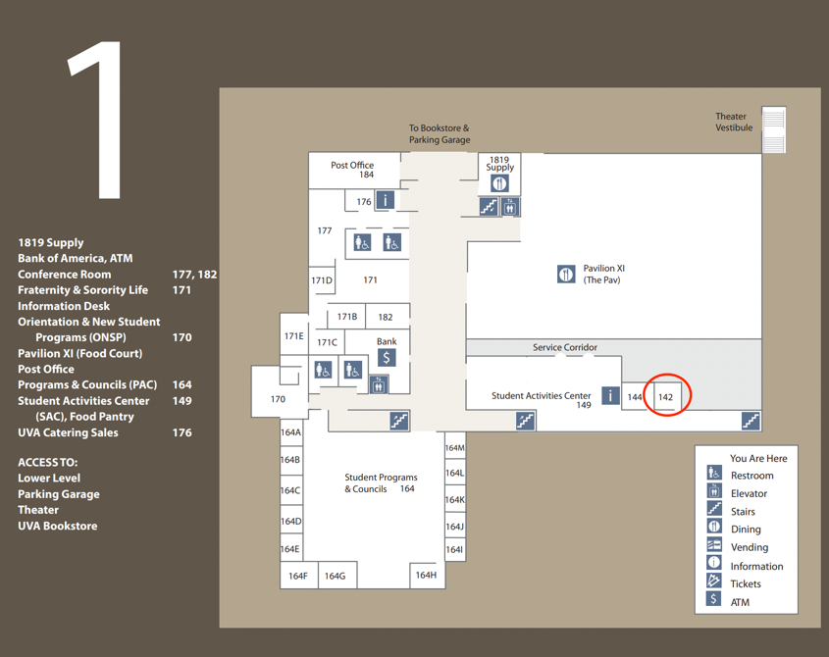
Donation Shelf
Backstock Room
Food Pantry

What do I wear? When you are volunteering with the pantry, please wear what you are comfortable in! There is no real dress code, we just ask that you do not wear clothing that is flashy/may indicate of wealth or status.
What do I need to know? Here is everything you need to know about your individual volunteer role. Please read all information before you start volunteering. Most of these roles are independent, thus it is important to understand what you are doing prior to serving with the pantry. No one is there to oversee you! Please let anyone on the executive team know if you are confused/think a resource should be added to this document.

Welcomer Information:
- Pantry Partner Program: An Introduction for Volunteers
- Role: Act as a welcoming guide to visitors in the CFP space.
- Main Tasks:
- Provide basic information about CFP.
- Connect visitors with additional resources.
- Special Assistance:
- Educate students on SNAP benefits.
- Inform about emergency financial aid.
- Highlight other support options.
- Analogy: Think of yourself as a Sherpa, leading people to valuable information.
- Setting: Functions like an info desk for CFP.
- Interaction: Initial greeting linked here - Community Support Corner Language.docx
- Offer resource list and business card for further support.
- Ideal Candidate:
- Enjoys social interaction.
- Values quiet time for personal tasks like homework.

LINK TO FOOD RESOURCES TO SHARE IN THE COMMUNITY SUPPORT CORNER

Pantry Maintenance Information:

Here is a link to the UVA CFP Pantry Maintenance Protocols

Backstock Restock Information:
Steps to a successful backstock Restock:
  - Enter the pantry (Room 142 in the Student Activities Center) and take a mental note of items that are running low or empty. These items are frequently snacks and pasta.
  - With items in mind, enter the backstock room (Room 144 in Student Activities Center) and collect items.
  - Load items onto the cart that is stored in the back stocking room and restock them into the pantry.
How much to Restock?
1-2 Carts worth of items is the perfect amount to restock. More than that, and we may run out of items too quickly, less and there may not be enough food to support our patrons.

Weekly Restock Information:
Steps for success:
- Meet your shift leader in the Student Activities Center
- Shift leader will guide you to the loading dock
- Load carts with groceries under supervision of shift leader
- Bring carts back to the pantry and restock items on the shelves
- Tidy up and organize the pantry as you are restocking
- Break down and throw away boxes
- Return carts

Who to contact with questions/cancelations:
Contact your shift leader with any questions, or last-minute cancelations!

How long do these shifts last?
These restocks can take anywhere from 30 minutes to 1.5 hours.

Driving: Reference information on Volunteer Power-Point linked on first page

Reapportionment: Reference information on Volunteer Power-Point linked on first page

